UNIT 2 Regular Expression

Regular Expression

* The language accepted by finite automata can be easily described by simple expressions called Regular Expressions. It is the most effective way to represent any language.
* The languages accepted by some regular expression are referred to as Regular languages.
* A regular expression can also be described as a sequence of pattern that defines a string.
* Regular expressions are used to match character combinations in strings. String searching algorithm used this pattern to find the operations on a string.

**For instance:**

In a regular expression, x* means zero or more occurrence of x. It can generate {e, x, xx, xxx, xxxx, .....}

In a regular expression, x+ means one or more occurrence of x. It can generate {x, xx, xxx, xxxx, .....}

Operations on Regular Language

The various operations on regular language are:

**Union:** If L and M are two regular languages then their union L U M is also a union.

1. 1. L U M = {s | s is in L or s is in M}

**Intersection:** If L and M are two regular languages then their intersection is also an intersection.

1. 1. L ⋂ M = {st | s is in L and t is in M}

**Kleen closure:** If L is a regular language then its Kleen closure L1* will also be a regular language.

1. 1. L* = Zero or more occurrence of language L.

### **Example 1:**

Write the regular expression for the language accepting all combinations of a's, over the set ∑ = {a}

**Solution:**

All combinations of a's means a may be zero, single, double and so on. If a is appearing zero times, that means a null string. That is we expect the set of {ε, a, aa, aaa, ....}. So we give a regular expression for this as:

1. R = a*

That is Kleen closure of a.

### **Example 2:**

Write the regular expression for the language accepting all combinations of a's except the null string, over the set ∑ = {a}

**Solution:**

The regular expression has to be built for the language

1. L = {a, aa, aaa, ....}

This set indicates that there is no null string. So we can denote regular expression as:

R = a+

### **Example 3:**

Write the regular expression for the language accepting all the string containing any number of a's and b's.

**Solution:**

The regular expression will be:

1. r.e. = (a + b)*

This will give the set as L = {ε, a, aa, b, bb, ab, ba, aba, bab, .....}, any combination of a and b.

The (a + b)* shows any combination with a and b even a null string.

# Examples of Regular Expression

### **Example 1:**

Write the regular expression for the language accepting all the string which are starting with 1 and ending with 0, over ∑ = {0, 1}.

**Solution:**

In a regular expression, the first symbol should be 1, and the last symbol should be 0. The r.e. is as follows:

1. R = 1 (0+1)* 0

### **Example 2:**

Write the regular expression for the language starting and ending with a and having any having any combination of b's in between.

**Solution:**

The regular expression will be:

1. R = a b* a

### **Example 3:**

Write the regular expression for the language starting with a but not having consecutive b's.

**Solution:** The regular expression has to be built for the language:

1. L = {a, aba, aab, aba, aaa, abab, .....}

The regular expression for the above language is:

1. R = {a + ab}+

### **Example 4:**

Write the regular expression for the language accepting all the string in which any number of a's is followed by any number of b's is followed by any number of c's.

**Solution:** As we know, any number of a's means a* any number of b's means b*, any number of c's means c*. Since as given in problem statement, b's appear after a's and c's appear after b's. So the regular expression could be:

1. R = a* b* c*

### **Example 5:**

Write the regular expression for the language over ∑ = {0} having even length of the string.

**Solution:**

The regular expression has to be built for the language:

1. L = {ε, 00, 0000, 000000, ......}

The regular expression for the above language is:

1. R = (00)*

### **Example 6:**

Write the regular expression for the language having a string which should have atleast one 0 and alteast one 1.

**Solution:**

The regular expression will be:

1. R = [(0 + 1)* 0 (0 + 1)* 1 (0 + 1)*] + [(0 + 1)* 1 (0 + 1)* 0 (0 + 1)*]

### **Example 7:**

Describe the language denoted by following regular expression

1. r.e. = (b* (aaa)* b*)*

**Solution:**

The language can be predicted from the regular expression by finding the meaning of it. We will first split the regular expression as:

r.e. = (any combination of b's) (aaa)* (any combination of b's)

L = {The language consists of the string in which a's appear triples, there is no restriction on the number of b's}

### **Example 8:**

Write the regular expression for the language L over ∑ = {0, 1} such that all the string do not contain the substring 01.

**Solution:**

The Language is as follows:

1. L = {ε, 0, 1, 00, 11, 10, 100, .....}

The regular expression for the above language is as follows:

1. R = (1* 0*)

### **Example 9:**

Write the regular expression for the language containing the string over {0, 1} in which there are at least two occurrences of 1's between any two occurrences of 1's between any two occurrences of 0's.

**Solution:** At least two 1's between two occurrences of 0's can be denoted by (0111*0)*.

Similarly, if there is no occurrence of 0's, then any number of 1's are also allowed. Hence the r.e. for required language is:

1. R = (1 + (0111*0))*

### **Example 10:**

Write the regular expression for the language containing the string in which every 0 is immediately followed by 11.

**Solution:**

The regular expectation will be:

1. R = (011 + 1)*

# Conversion of RE to FA

To convert the RE to FA, we are going to use a method called the subset method. This method is used to obtain FA from the given regular expression. This method is given below:

****Step 1:**** Design a transition diagram for given regular expression, using NFA with ε moves.

****Step 2:**** Convert this NFA with ε to NFA without ε.

****Step 3:**** Convert the obtained NFA to equivalent DFA.

### Example 1:

Design a FA from given regular expression 10 + (0 + 11)0* 1.

****Solution:**** First we will construct the transition diagram for a given regular expression.

****Step 1:****

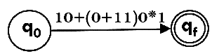

****Step 2:****

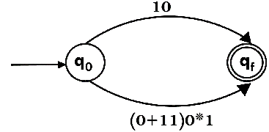

****Step 3:****

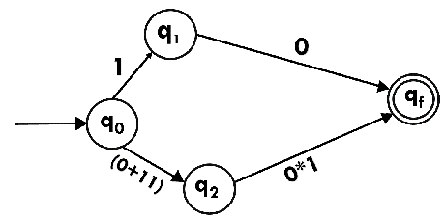

****Step 4:****

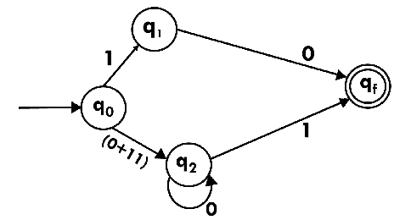

****Step 5:****

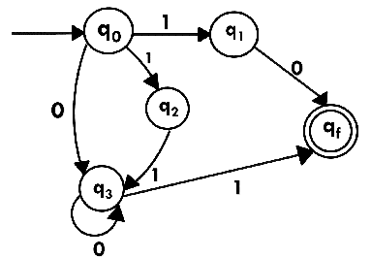

Now we have got NFA without ε. Now we will convert it into required DFA for that, we will first write a transition table for this NFA.

|  |  |  |
| --- | --- | --- |
| **State** | **0** | **1** |
| →q0 | q3 | {q1, q2} |
| q1 | qf | ϕ |
| q2 | ϕ | q3 |
| q3 | q3 | qf |
| *qf | ϕ | ϕ |

The equivalent DFA will be:

|  |  |  |
| --- | --- | --- |
| **State** | **0** | **1** |
| →[q0] | [q3] | [q1, q2] |
| [q1] | [qf] | ϕ |
| [q2] | ϕ | [q3] |
| [q3] | [q3] | [qf] |
| [q1, q2] | [qf] | [qf] |
| *[qf] | ϕ | ϕ |

### Example 2:

Design a NFA from given regular expression 1 (1* 01* 01*)*.

****Solution:**** The NFA for the given regular expression is as follows:

****Step 1:****

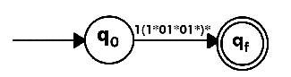

****Step 2:****

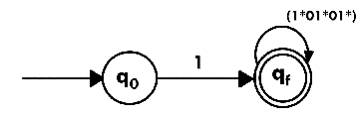

****Step 3:****

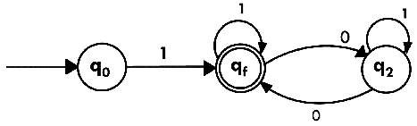

### Example 3:

Construct the FA for regular expression 0*1 + 10.

****Solution:****

We will first construct FA for R = 0*1 + 10 as follows:

****Step 1:****

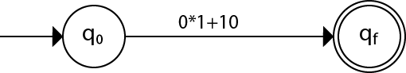

****Step 2:****

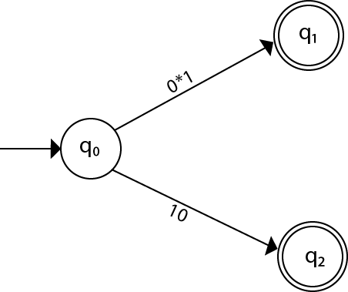

****Step 3:****

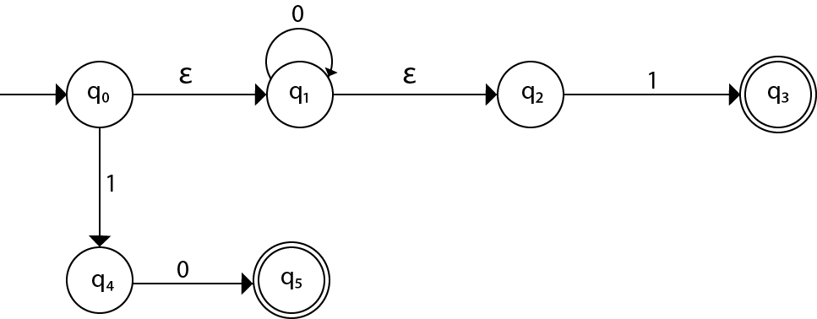

****Step 4:****

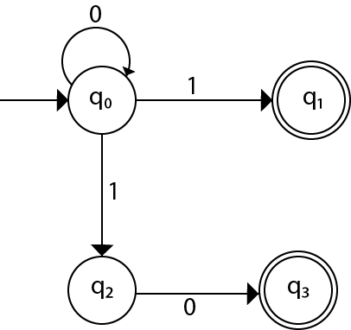

# Arden's Theorem

The Arden's Theorem is useful for checking the equivalence of two regular expressions as well as in the conversion of DFA to a regular expression.

Let us see its use in the conversion of DFA to a regular expression.

Following algorithm is used to build the regular expression form given DFA.

1. Let q1 be the initial state.

. There are q2, q3, q4 ....qn number of states. The final state may be some qj where j<= n.

3. Let αji represents the transition from qj to qi.

4. Calculate qi such that

qi = αji * qj

If qj is a start state then we have:

qi = αji * qj + ε

5. Similarly, compute the final state which ultimately gives the regular expression 'r'.

### Example:

Construct the regular expression for the given DFA

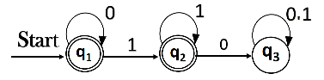

****Solution:****

Let us write down the equations

q1 = q1 0 + ε

Since q1 is the start state, so ε will be added, and the input 0 is coming to q1 from q1 hence we write  
State = source state of input × input coming to it

Similarly,

q2 = q1 1 + q2 1

q3 = q2 0 + q3 (0+1)

Since the final states are q1 and q2, we are interested in solving q1 and q2 only. Let us see q1 first

q1 = q1 0 + ε

We can re-write it as

q1 = ε + q1 0

Which is similar to R = Q + RP, and gets reduced to R = OP*.

Assuming R = q1, Q = ε, P = 0

We get

q1 = ε.(0)*

q1 = 0* (ε.R*= R*)

Substituting the value into q2, we will get

q2 = 0* 1 + q2 1

q2 = 0* 1 (1)* (R = Q + RP → Q P*)

The regular expression is given by

r = q1 + q2

= 0* + 0* 1.1*

r = 0* + 0* 1+ (1.1* = 1+)